TOWN OF BRIDGTON
DEPUTY TOWN MANAGER’S REPORT
September 26, 2017

Personnel

Robert “Bob” Fitzcharles Sr., Transfer Station Manager, has returned to work on this date after an extended leave of absence. I would like to thank Jim Kidder, Public Works Director, for supervising the facility during Bob’s absence and thank the Transfer Station Crew for their efforts in maintaining facility operations flawlessly.

I would like to congratulate Brenda Day, Administrative Assistant, for successfully completing the State of Maine Internal Plumbing and Subsurface Wastewater examinations. This gives Brenda the authority to inspect septic systems and plumbing installations. This advancement gives the Town a back-up when Rob Baker, Code Enforcement Officer, is unavailable. Congratulations Brenda!

Fire Chief, Steve Fay, applied and has been accepted for attendance into the National Fire Academy (“NFA”) located in Emmitsburg, Maryland on January 14, 2018 to January 19, 2018. The Academy is governed by the United States Fire Administration offering a curriculum that provides specialized training and education not otherwise available through state fire training agencies and local fire departments.

In September George Szok, Bridgton Grant Writer, submitted three grant applications totaling $11,690.00. $7,150 is through the Coulombe Foundation for Summer Camp and the remaining $4,540 is through MMA for office desk sets and various police related items.

Granite Stones

The granite stones from the Moose Pond Causeway are available at a cost of $300.00 per stone. The Town reserves the right to limit the number of stones per individual. Arrangements must be made with Jim Kidder, Public Works Director, at 647-1127. The purchaser must pay in advance of picking the stones up at Public Works. The proceeds from the stones will be deposited into the Moose Pond Trust Fund.

Domestic Violence Awareness Month

October is Domestic Violence Awareness Month. Purple Light Nights brighten our community by getting involved #takeastand. If you or someone you know if being abused please call the confidential hotline at 1-800-537-6066. On October 1st you will see strings of purple lights displayed as a way to say Domestic violence has NO place in our community!

Vandalism and Arson

Over the past several months there has been an increase in vandalism throughout town, most recently this morning there were four separate fires beginning at 2:19a.m. at Highland Lake Beach resulting in a total loss of the lifeguard station including all the equipment stored for the season followed by three separate port-a-pottie fires (behind Bridgton Books, behind Stevens Brook Elementary School and at Harmon Field.) The State Fire Marshal’s Office has been contacted to conduct an investigation into these incidents. If you have any information, saw any suspicious activity or have surveillance cameras which may have picked up any suspicious activity during this time-frame please contact the Bridgton Police Department immediately at 207-647-8814. Arson is a serious crime and will not be tolerated. Further, taxpayer’s money is spent to improve and beautify the Town with

Various Departments maintaining the infrastructure during the best and worst of weather conditions only to have it heinously and needlessly destroyed. We are asking that the public be vigilant and assist in any way possible to prevent further destruction of our town’s amenities by reporting any suspicious activity to the Bridgton Police Department immediately.

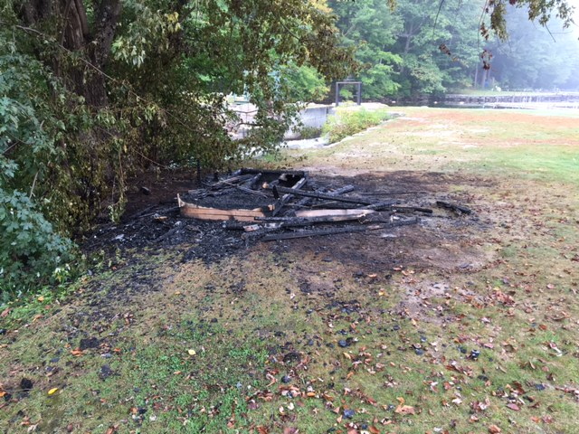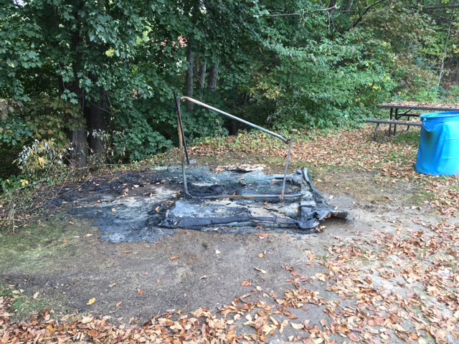
Lifeguard Station Behind Bridgton Books

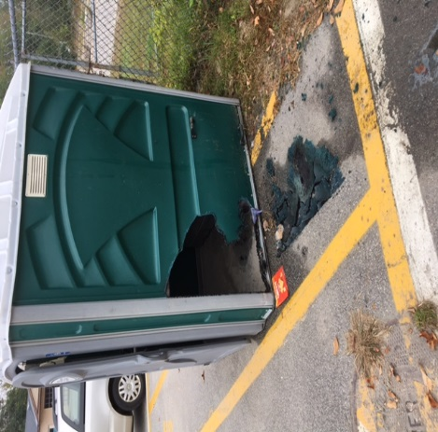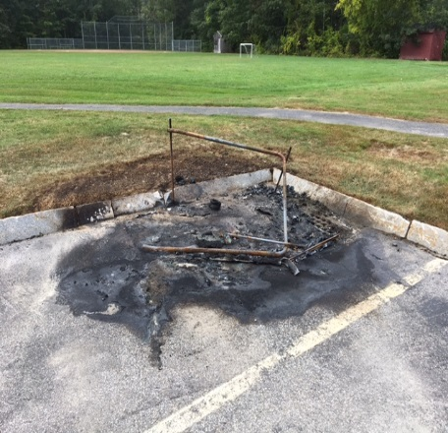
Stevens Brook Elementary School Harmon Field

Respectfully submitted,

Georgiann M. Fleck
Deputy Town Manager

