

**TOWN OF BRIDGTON**

**DEPUTY TOWN MANAGER’S REPORT**

**June 26, 2018**

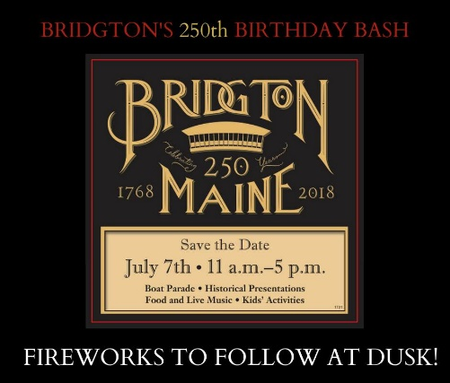Bridgton is celebrating its 250th birthday with a “Birthday Bash” on July 7th. Lots of celebratory events are planned so mark your calendar and come out to help us celebrate a very important day in the history of our Town.

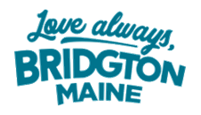

**GENERAL**

***Bureau of Motor Vehicles*** - Effective July 5th the mobile unit located at the Bridgton Municipal Complex in the downstairs meeting room, 10 Iredale Street, Bridgton will be here on the first and last Thursday and second Tuesday 10:30a.m. to 1:30p.m. (The days remained the same but the hours of operation changed).

**FIRE DEPARTMENT**

Work continues on the ***airboat restoration*** with another 20 man hours completed this past Sunday. The Fire Chief would like to thank the ***Bridgton News for their assistance in continuing our recruitment drive*** with weekly advertisements. ***Burn Permits*** are required for certain outside fires and are easily acquired at <http://www.burningpermit.com> at no charge. Permits will not be issued above a “Medium” classification. Thank you to Chief Andy Dufresne of the Fryeburg Fire Department for the **donation** of five International Fire Service Training Association ***Essentials of Fire Fighting, 6th Edition*** manuals. These books are brand new, meet the requirements for NFPA 101 Standards and are an integral part of the modernization program toward training. The Fire Chief would like to ***welcome*** seasonal guests and tourists back to Bridgton and wish everyone a safe and enjoyable summer.

**POLICE DEPARTMENT**

*[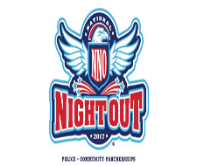](http://www.google.com/url?sa=i&rct=j&q=&esrc=s&source=images&cd=&cad=rja&uact=8&ved=0ahUKEwiussyR9qTVAhVFGj4KHXadAQoQjRwIBw&url=http://pittsburghpa.gov/publicsafety/nno/&psig=AFQjCNHlgLCmRx30az0KfZnOpZ4JfTMaeg&ust=1501088918331355)*Please join the Bridgton Police Department for ***National Night Out*** on August 7th from 5:00p.m. to 7:00p.m. at Harmon Field for people of all ages. This is a community-building campaign to enhance the relationship between police, fire and the community. Nationally, millions take part in this campaign on the first Tuesday in August hosting and participating in block parties, festivals, parades, cookouts, safety demonstrations and exhibits. Let’s make Bridgton’s second year of participation even greater than the first. We would like to welcome Brogan Horton as Bridgton’s new ***Animal Control Officer.***

**RECREATION**

***Swim lessons*** and ***summer rec camp*** began on Monday, June 25th. For the safety of our beach goers ***Lifeguards*** are now stationed at Highland Lake Beach. Independence Day Celebration kicks off with Bridgton fireworks on Tuesday, July 3rd at Stevens Brook Elementary School and the Bridgton Lions 4th of July parade

on Wednesday, July 4th. The theme for the parade is “Happy Birthday Bridgton 250 years”. For more information contact Bob McHatton at 647-4280. There is a Cabbage Island Adult Trip planned on August 10, 2018. If interested, you may sign up at The Bridgton Town Office. Registration has begun for **fall soccer**. For more information on summer rec programs and fall soccer registration please refer to our website at [www.bridgtonmaine.org](http://www.bridgtonmaine.org).

(As you can see) we have installed a ***60” TV*** to use for presentations during meetings, trainings and LRTV will be doing their newsfeed during the day. I want to thank Public Works and LRTV for getting it installed and operational.

Respectfully submitted,

Georgiann M. Fleck

Deputy Town Manager

 