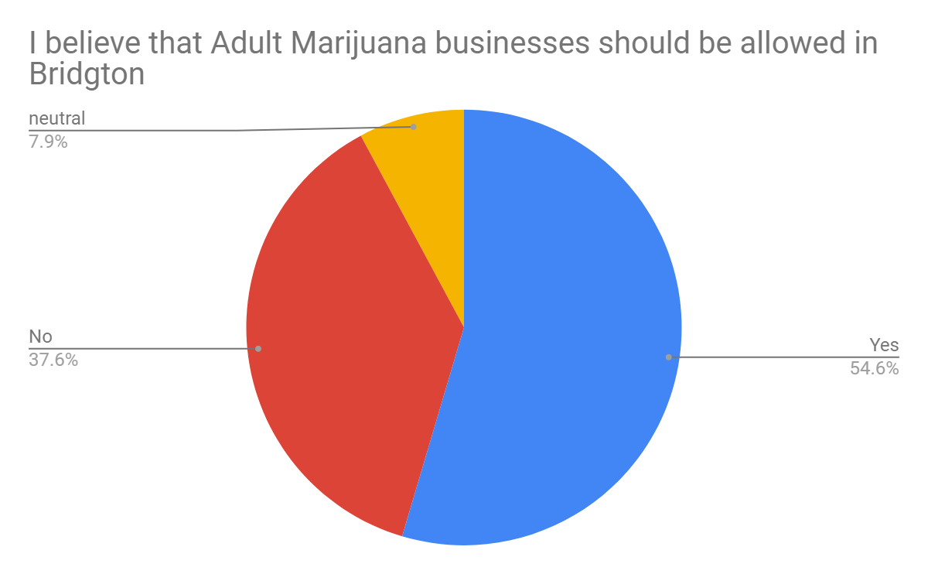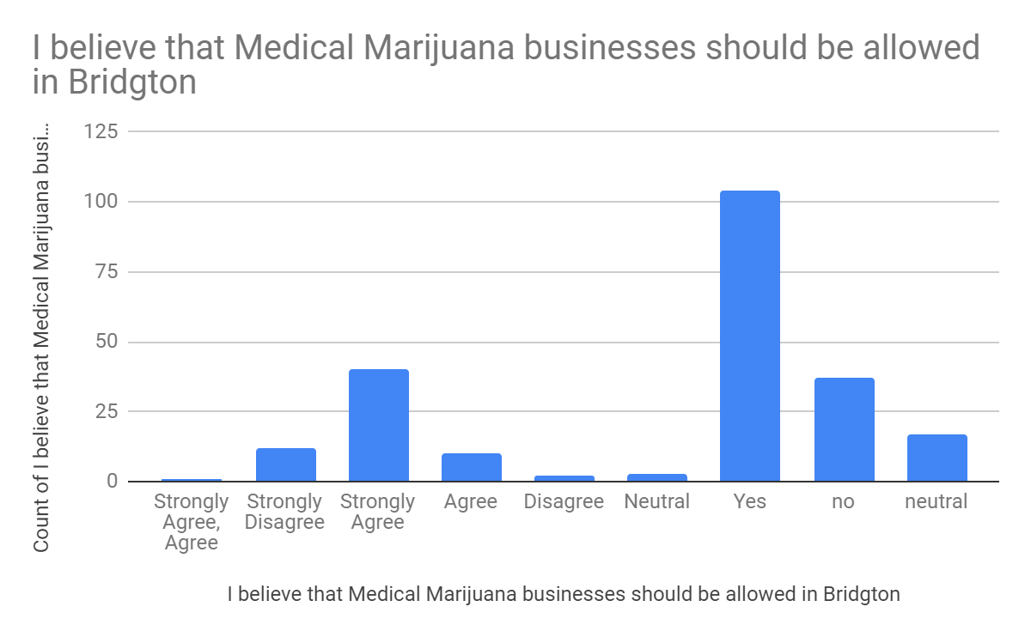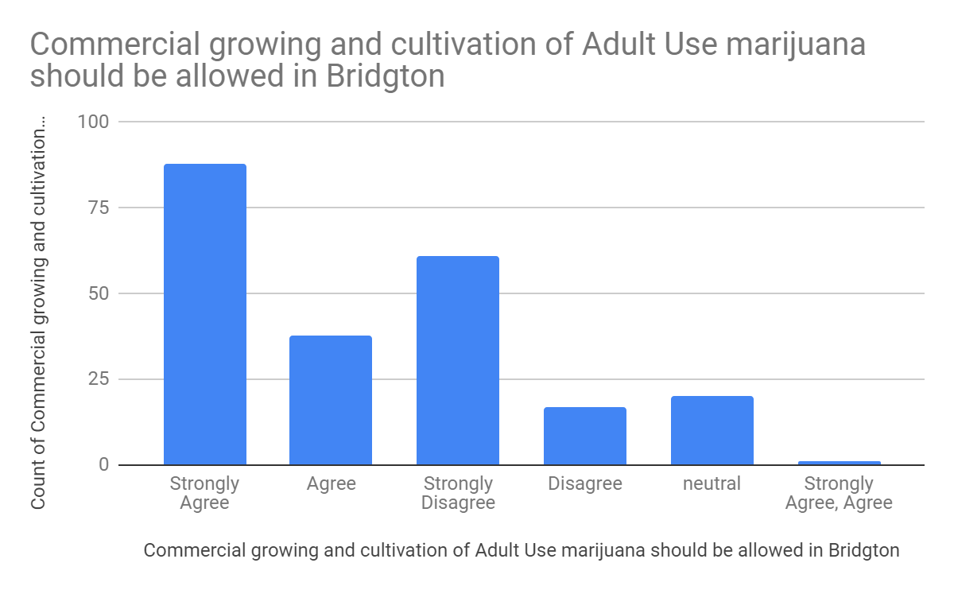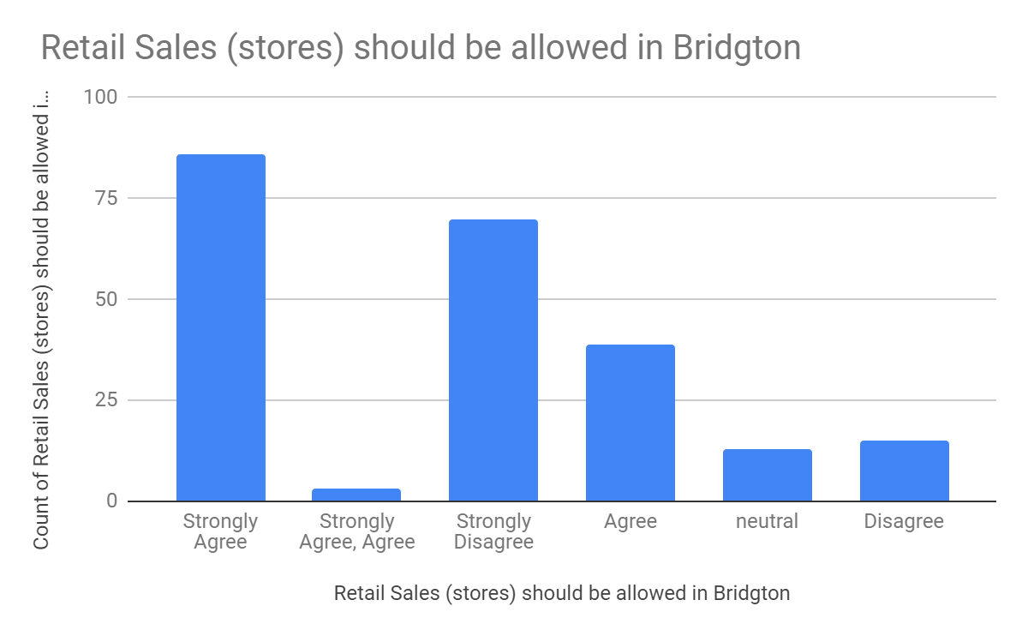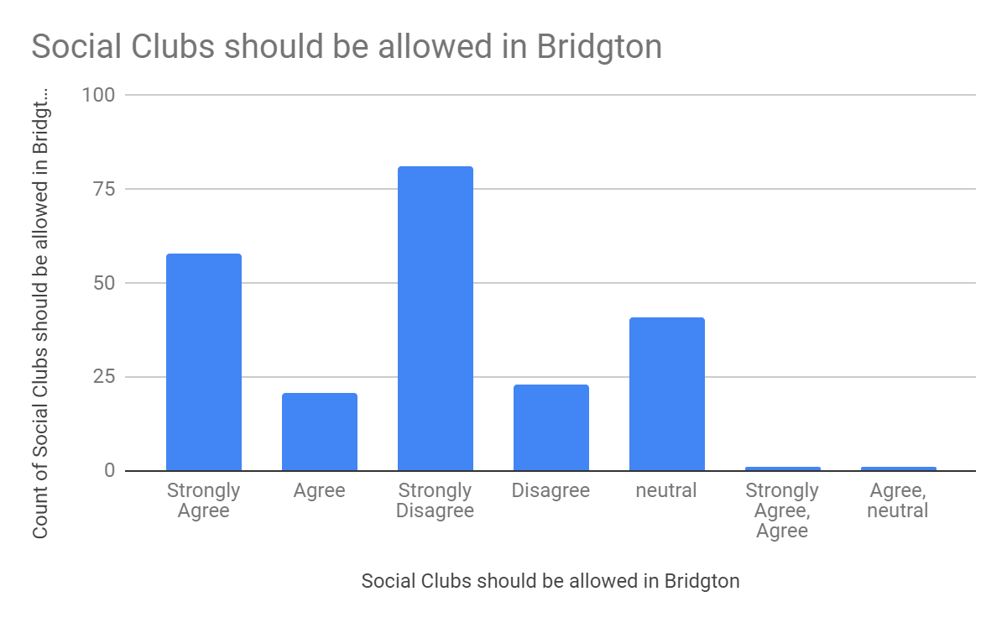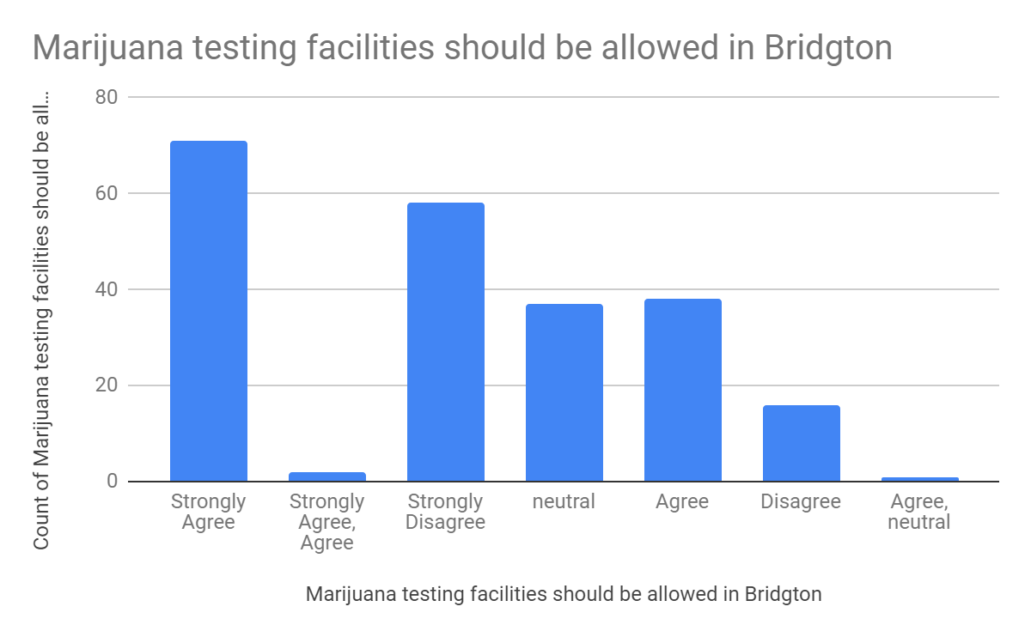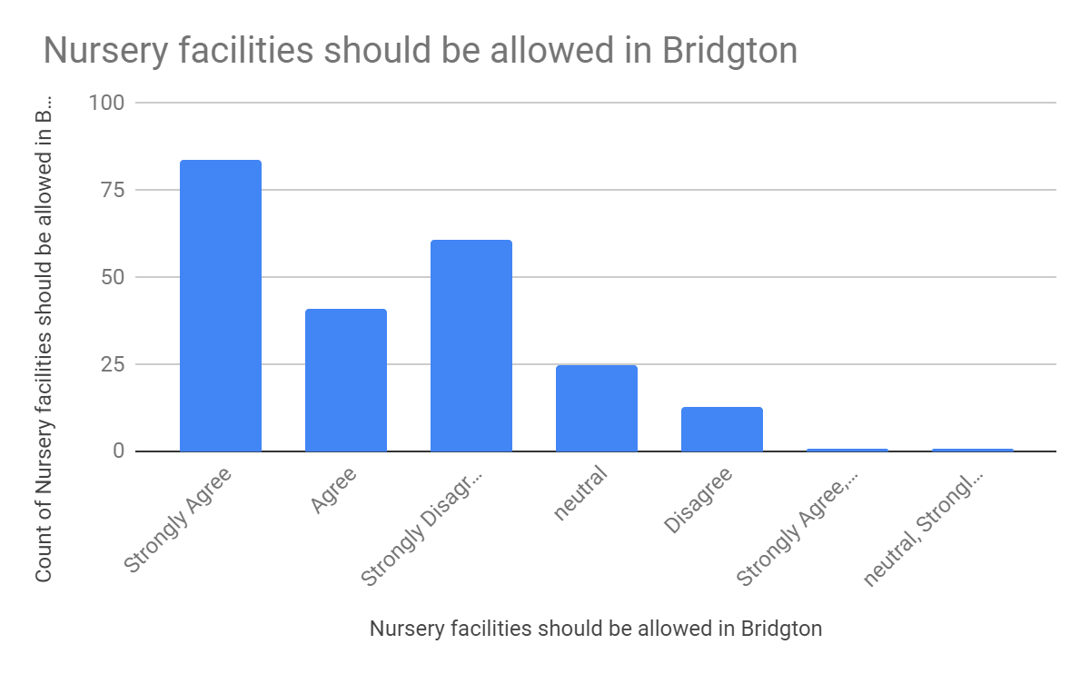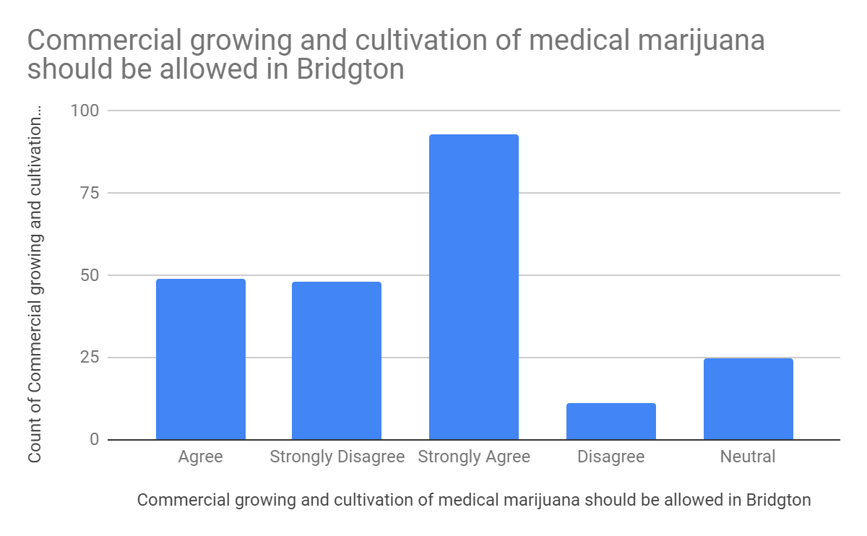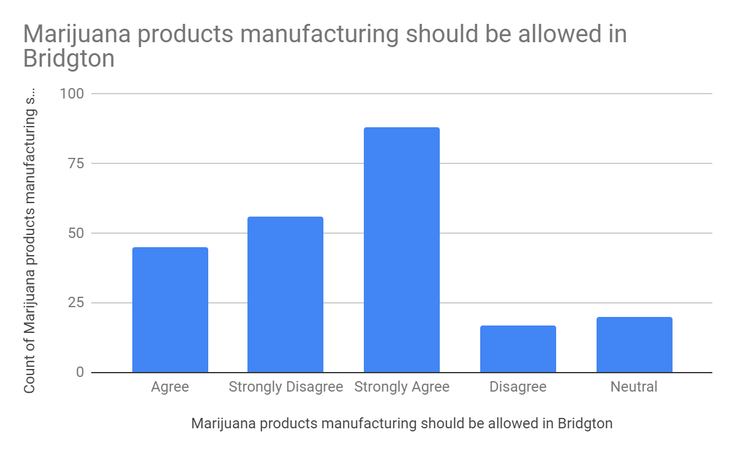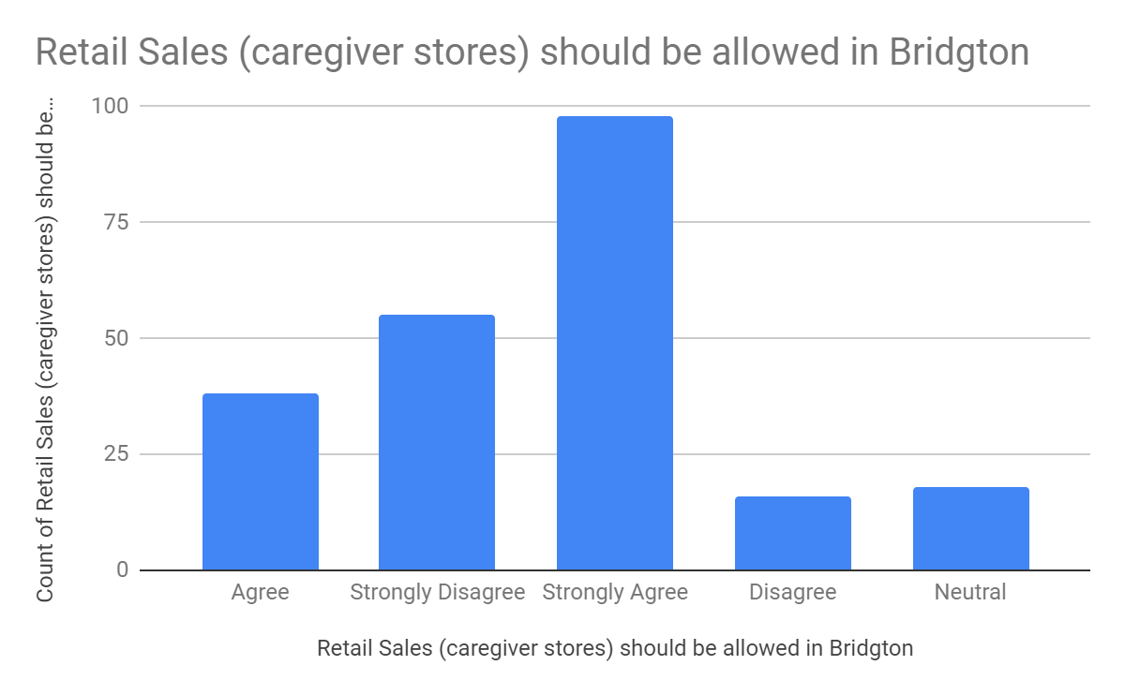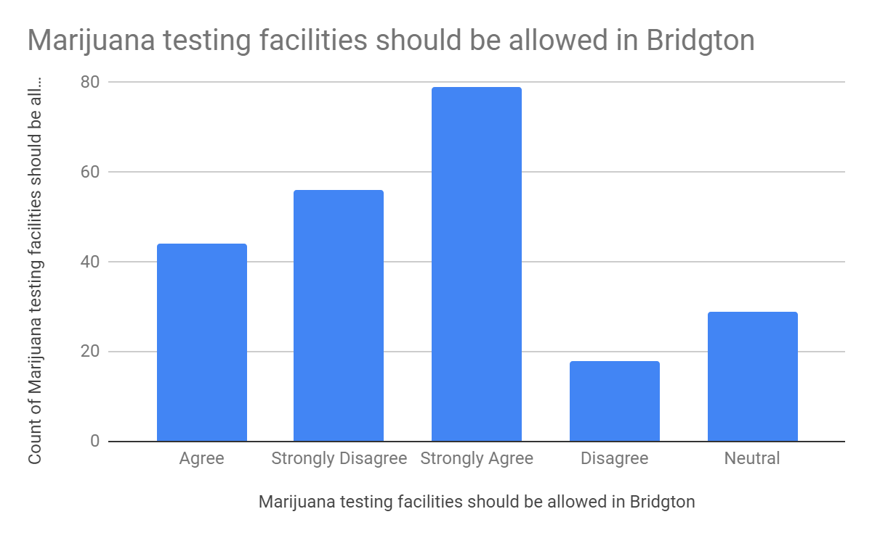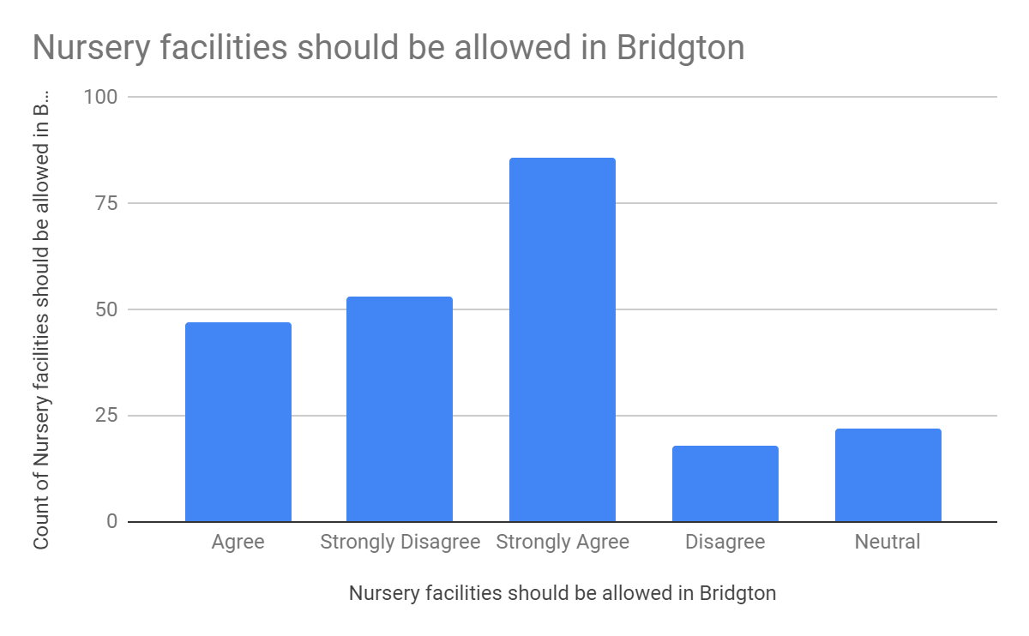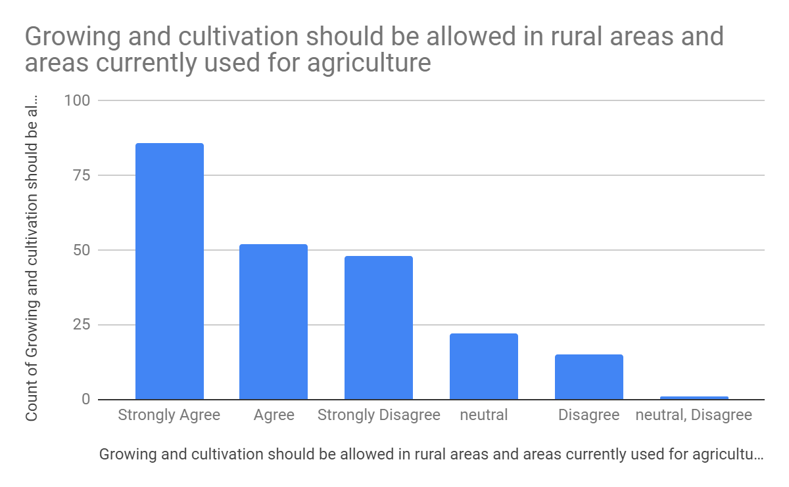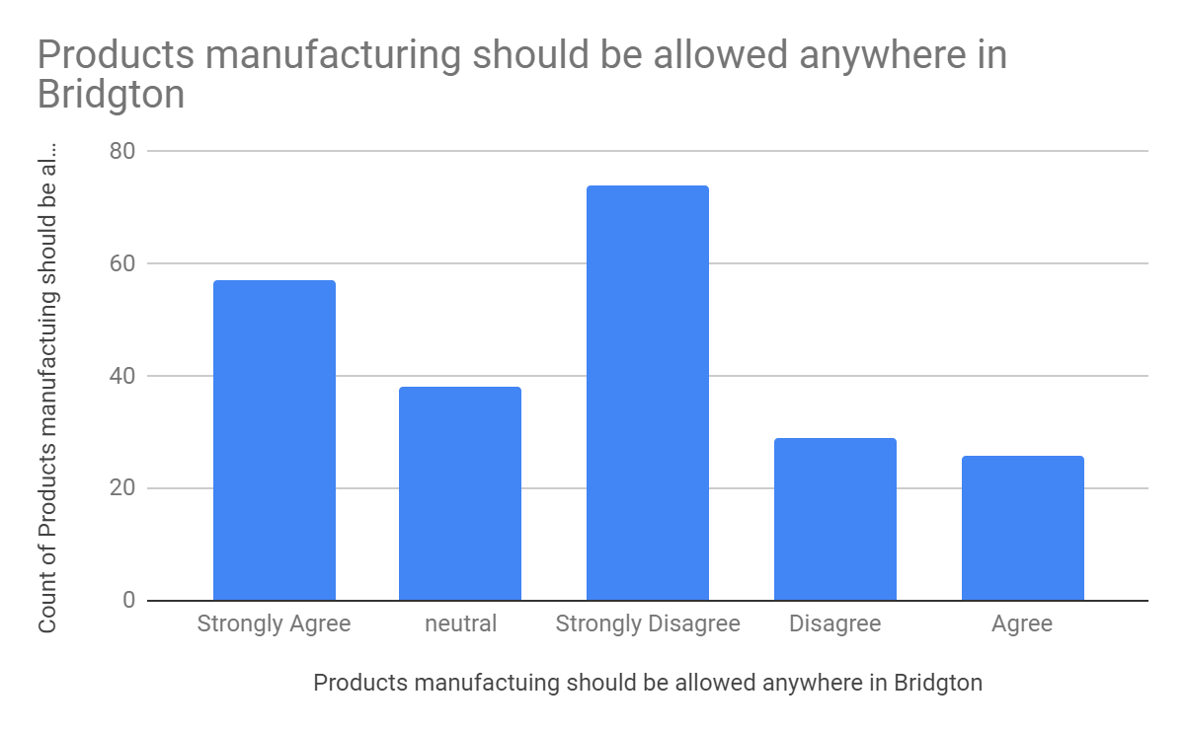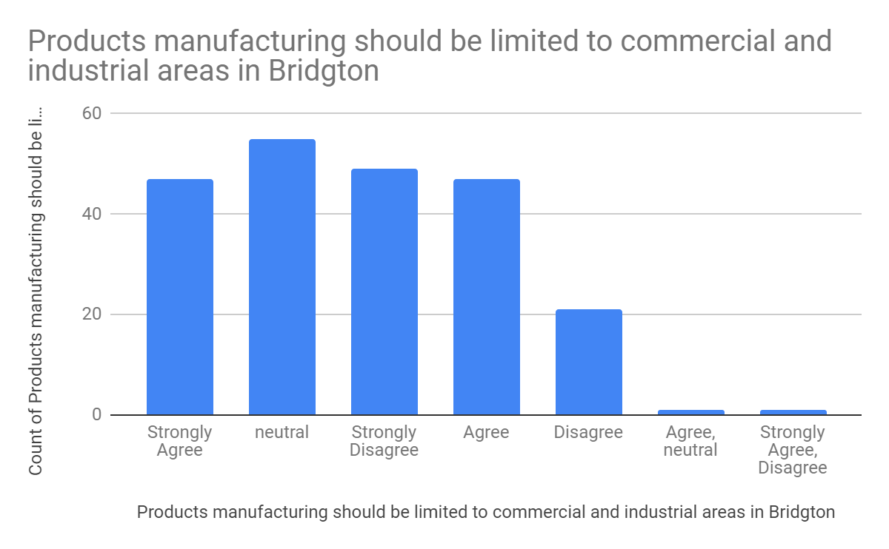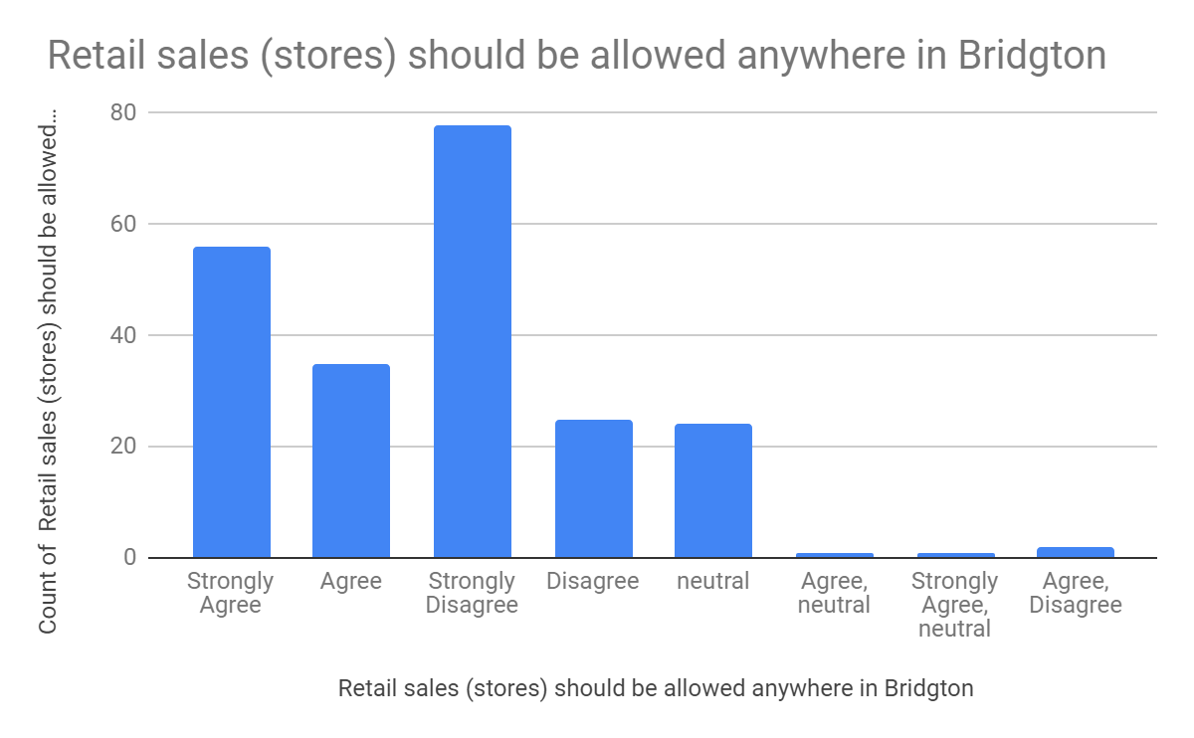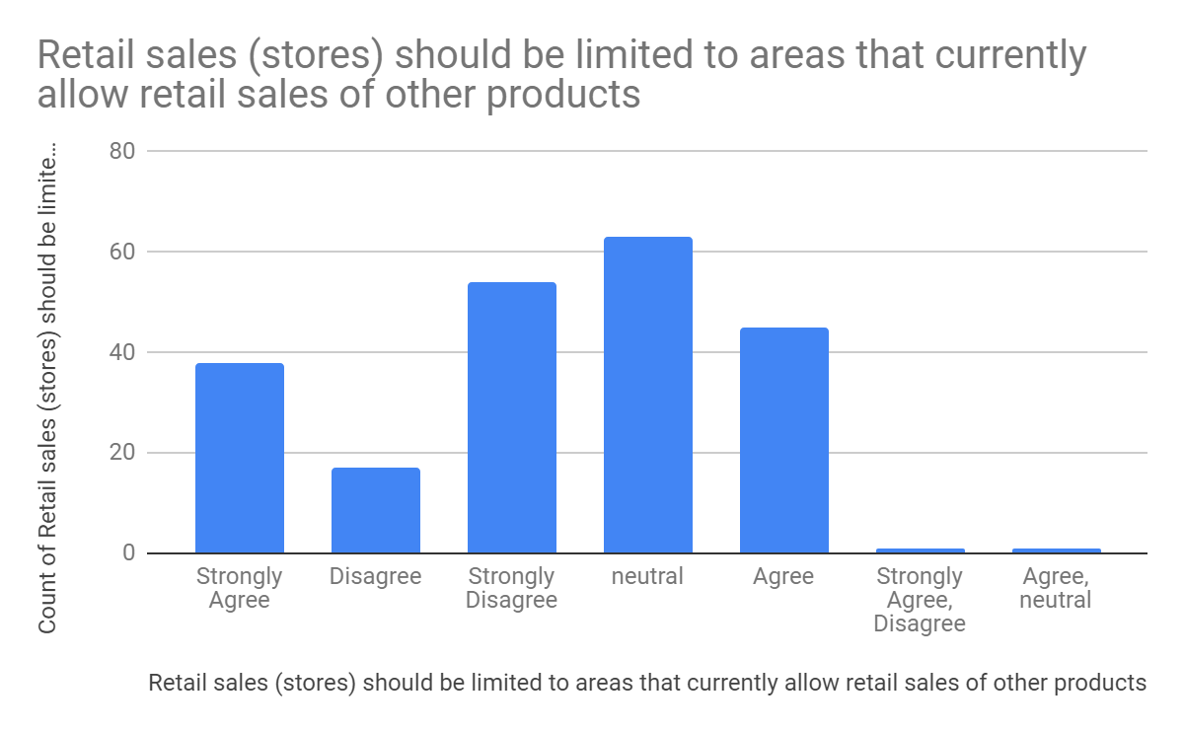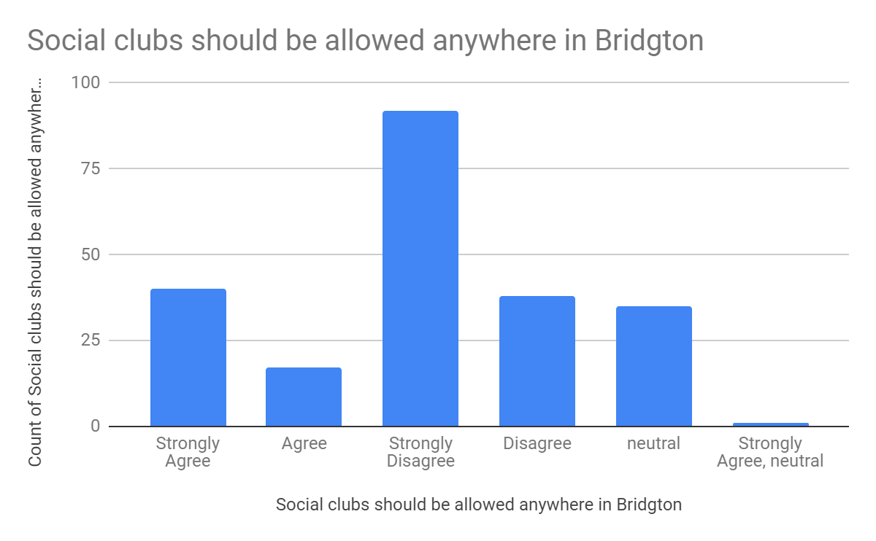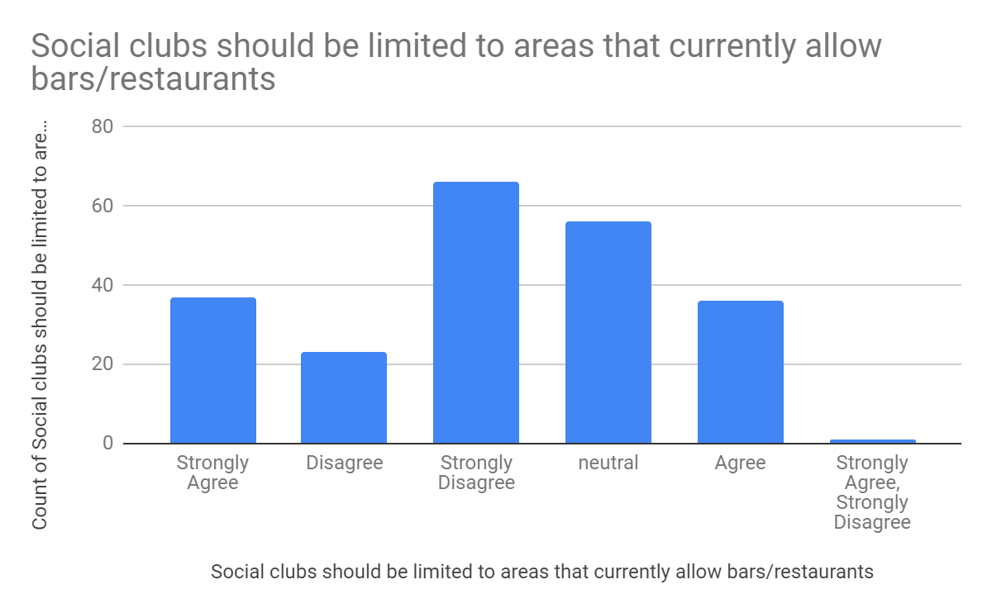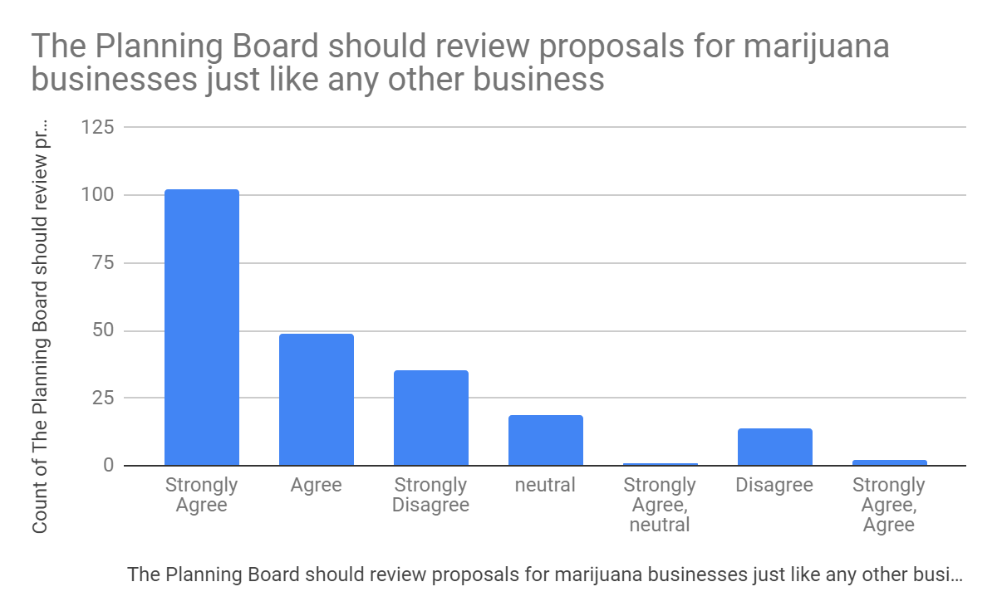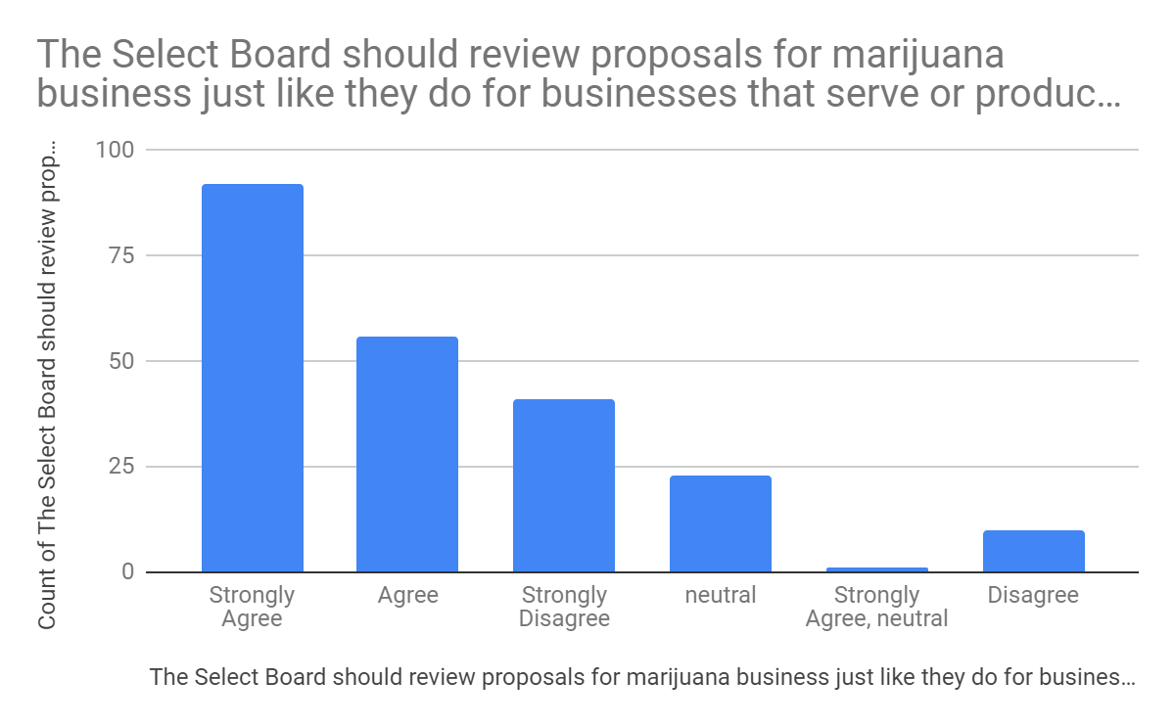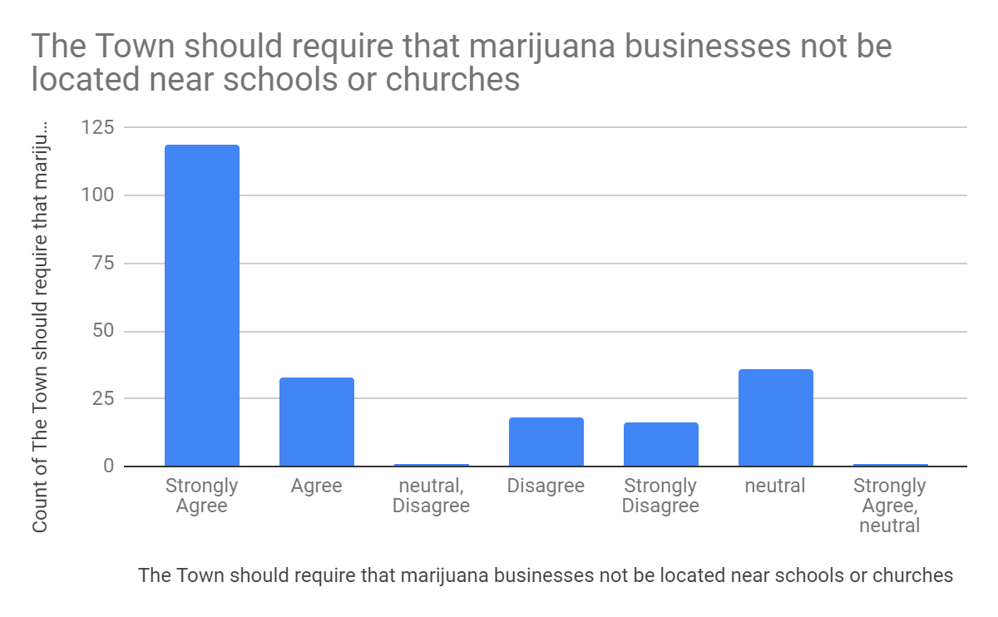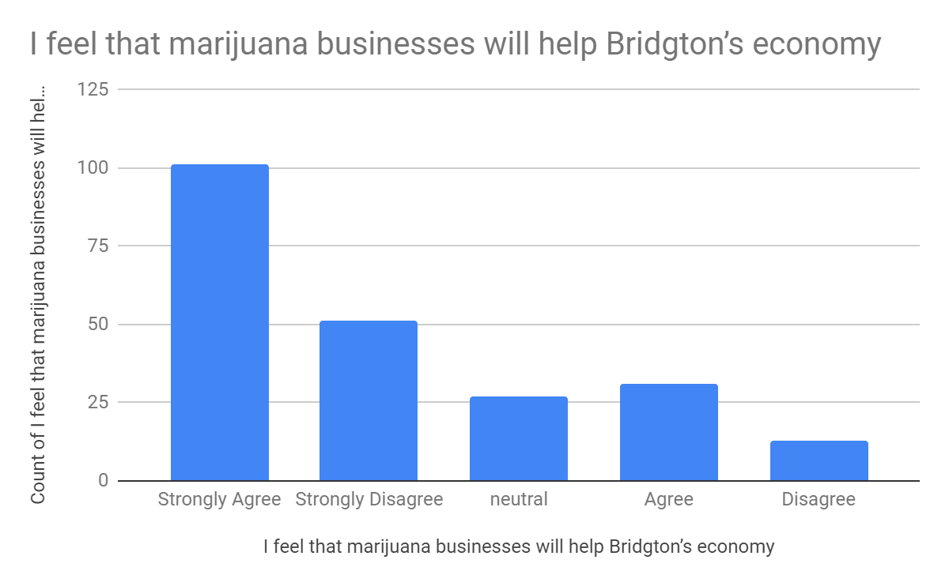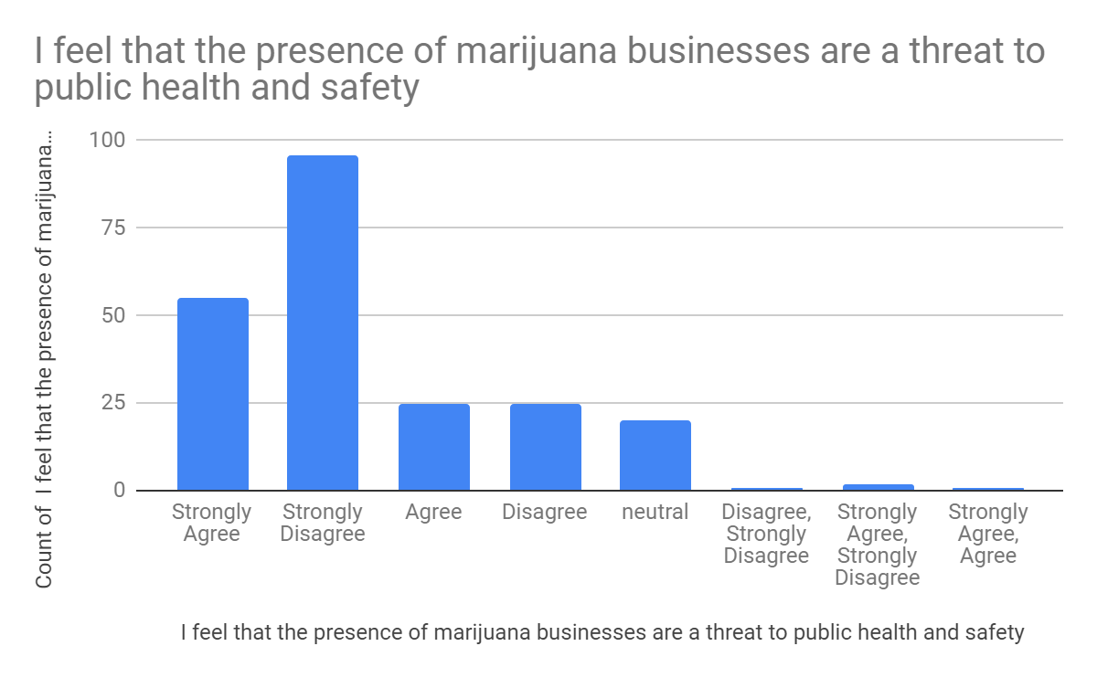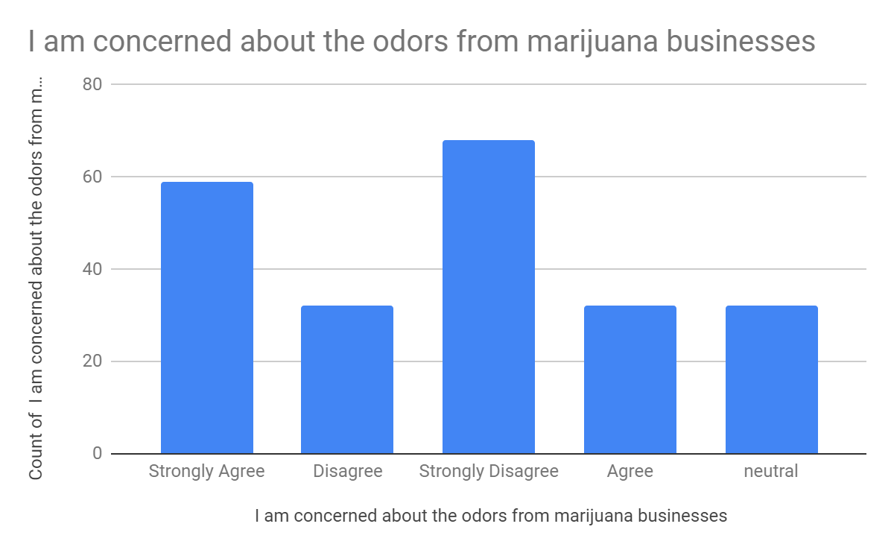

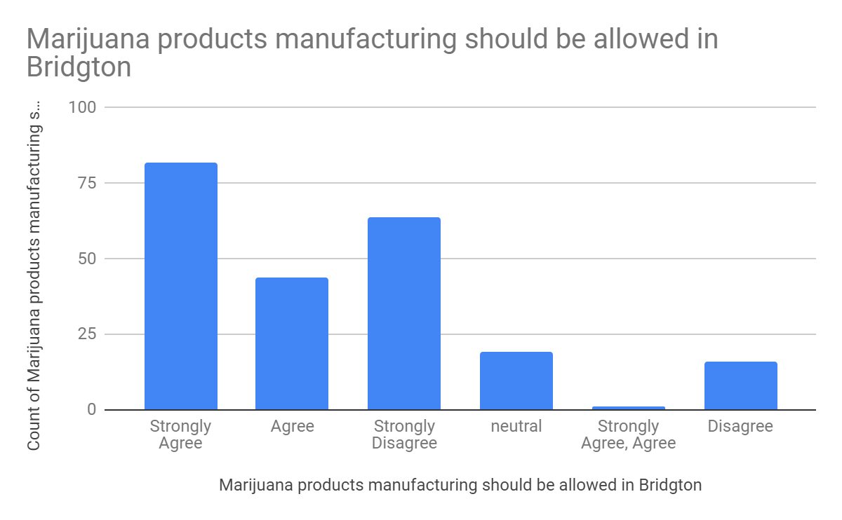

over the last 45 years Bridgton has maintained its uniqueness by letting others-N. conway, windham, etc take the onus of strip malls, large-box stores, and residential unfriendly operations. Let's continue to do so.
I strongly protest legalization of marijuana for any reason, even medical. It is a gateway drug and should be recognized as such.
it will bring in people we don't want into this town. Nothing but trouble for our community.
medical marijuana only-regulated by doctors or town officials
medical products is positive. social product and its multiple side effects are negative and should not be endorsed/coat tailed to marijuana medical
Fryburg is allowing retail sales. Bridgton will lose out on a lot of tax dollars if it isn't allowed. If you allow bars and liquor stores then you should allow retail sales of cannabis and social clubs. I understand the importance of keeping the odor down. This can be done with charcoal filters. Apprehension about social clubs is understandable but in my opinion retail sales done correctly shouldn't be.
Here's our chance. Let's do it right.
It’s legal and should be treated as any other legal business
This would be a huge benefit for bridgton!
Will help with tax base, sick of my property taxes going up every year.
Will attract people who will be a detriment to Bridgton and reduce its attractiveness to businesses, shoppers, and new residents
This would help out a lot more people then you think if you allowed this...please and thank you.
Start slow by limiting licenses issued and approve the most established cannabis company that Bridgton attract. ~duppy
I am excited to see Bridgton evaluating marijuana businesses. As long as only responsible businesses are granted permits and the town provides oversights to ensure proper use and distribution, this would be a great addition to the town.
Think of the much needed income it will bring to our state/town!
Should have a same Security‎ system as bank has and a built-in vault to keep the marijuana in
I would not like to see Bridgton become a drug mecca.
Please.do not allow marijuana to be smoked in public places.
The time has come don't drag it out!
Please don't ruin a beautiful tourist town with marijuana businesses. Let Bridgton be the wonderful vacation spot that it has always been for families without Marijuana businesses and all the potential problems that come along with - drugs!
Allowibf marijuana cultivation and sales will provide a wonderful opportunity for growth for the town of Bridgton
This type of business has no place in our town.
We have enough drug related problems wth out getting involved wth the growth and distribution of another mind altering drug.
The community is in great need of additional, year-round job opportunities and the town is in need of the additional retail tax. There is no downside to moving ahead with adult-use and medical-use marijuana. Regarding public health concerns, marijuana actually poses less of a threat than alcohol and tobacco products, so this should not be a valid argument to prevent the town moving forward with this. I'm also aware of several residents who use medical marijuana to manage chronic pain; it would be beneficial for these townspeople to have dispensaries locally situated.
I do not feel that any type of marijuana businesses would be good for the Bridgton Community. I do not wish to see any type of business that deals with marijuana in any capacity here in Bridgton!
My only concern is the odors impact to local tourism; the number 1 revenue growth in our towns economy. It’s very family driven, and marijuana odor may deter families from coming.
I feel that extending marijuana- related business beyond that which is currently allowed is a serious mistake. I do not believe that we would see economic gains. In fact, the presence of retail stores will most likely discourage some potential shoppers, vendors and homeowners to visit or locate in town. It would also add burdens and expense to the services such as the police department. Is this the image we hope to project? Most importantly, what is the message to our children and youth? We are attempting to respond to an opioid crisis. Adding more access and promoting drug use is not the way to support resolution to this important public health issue. Lastly, use of marijuana has been proven to have a negative effect on those with emerging mental illness. They tend to have more serious symptoms, become ill at a younger age and see less success in treatment. All of the above reasons should discourage the town from chasing a quick buck.
The people of Maine have spoken. Stop dragging your feet and implement some regulations. No more bans. Do your jobs.
Biggest concern is "Stores" need to be in commercial areas with adequate parking, not private residential neighborhoods where large amounts of "customers" are gathering in a party atmosphere and cars are parking on or blocking private property. Stores should not interfere with residential neighborhoods or their private property or disrupt the nature of privacy of the residents.
. .Eadibles only :) Pot cigarettes will cause cancer in the State of Maine , lip cancers, throat , & upper repiratory illnesses. /s, a Dr.
I think cannabis is great, as long as it is properly regulated. So many of these caregivers are not following the law and should not be able to continue ignoring them. Legitimate businesses whose taxes help our town should be allowed.
This is the start of a slippery slope. To those charged with the enforcement of the existing state statutes , I urge you to move cautiously ;don't be afraid to be creative in facing the known problems. In addition use your best judgement to look ahead to see how this fits in with what our town can become and insure the best interests of ALL residents of Bridgton into the foreseeable future. Good luck.
I am concerned about people who are stoned getting behind the wheel of a vehicle and going to work.
Thank you for allowing a forum for all of us to provide our opinions on this matter.
We cannot give an inch on this, because it will only lead to worse developments later. It may seem harmless now, but saying yes to this will only make it easier in future when groups may later push for things we absolutely don't want. It's the principle of it; I do not actually care about marijuana, but saying no to this today stops special interest groups form pushing for harder drugs 10 years from now because "we already allow weed". I'm afraid for our future, and my children's future, and want to take a hard-line no quarter stance now to prevent future problems from arising once weed becomes socially acceptable.
We already have an opioid crises in our community. Let's not perpetuate it with available marijuana stores. Having medical or retail shops in Bridgton will require more police for the safety of people and shops. People will drive under the influence of marijuana just like some already do with alcohol. It's a can of worms waiting to burst if we have this in Bridgton. Also, we have a fair amount of citizens that are subsidized by the state in some form. Do you really want some of these people to further check out of life smoking your tax dollars away?
There is a lot of money to be made in the marijuana business. As long as its a taxable business, and revenue can be made from it, AND its safely grown without the unknown factor I am in agreement with it for medical purposes only. Not a social club to sit around and smoke dope.
The Planning Board should NOT chose to allow Bridgton to have these stores. The Planning Board should preserve the safe, peaceful, quaint nature of Bridgton and prevent these stores from being allowed. These stores would be a cultural and moral travesty to our community and send a terrible message to our youth.
I am concerned about the large use of power as well as large use and pollution of water used in the business of growing pot. These issues have created problems in other communities. I do not want to see pot sold or served anywhere in Bridgton. We already have 3 medical pot businesses. That's enough. What is a pot testing facility? What kind of pot products are you talking about that would be manufactured? You could provide more information which could bring you better feedback.
We already have enough drugs in Bridgton and other problems. Why would we welcome it to cause more issues!?
In the early 1970s in Portland, "they" took old homes through eminent domain and built cheap apartments saying it would attract young, vibrant workers to the city. Instead it attracted people with little to no money, those with poor work ethics, those with mental health issues, etc. It ended up costing the city much more money in police, education, and social services. I'm afraid of a similar situation with allowing marijuana businesses and agriculture. Don't fall prey to the quick money scheme. It will cost Bridgton in the long run.
MARIJUANA SHOULD *NOT* BE ALLOWED IN BRIDGTON UNTIL WE CAN TEST TO SEE IF DRIVERS ARE DRIVING UNDER THE INFLUENCE OF MARIJUANA OR COMMITTING CRIMES UNDER THE INFLUENCE OF MARIJUANA
ALCOHOL KILLS MORE THAN MARIJUANA
CONCERNED ABOUT DRIVERS DRIVING UNDER TH EINFLUENCE OF MARIJUANA. DO WE HAVE EQUIPMENT TO TEST DRIVERS FOR UNDER INFLUENCE? DOES ENFORCEMENT DEPT NEED ADDITIONAL TRAINING FOR ABOVE?
DON'T "OPT IN" FOR ADULT MJ USES
RESIDENT COMING FROM COLORADO (LEGAL SINCE 2014) - REMARKABLE TAX REVENUE WITH NEGLIGIBLE EFFECT ON PUBLIC SAFETY AND HEALTH
TAXING MARIJUANA WOULD STRONGLY HELP NOT JUST BRIDGTON, BUT THE STATE IN GENERAL: SCHOOL FUNDING, ETC
THESE BUSINESSES (RETAIL/SOCIAL CLUBS) WILL BRING A TACKY ELEMENT TO OUR QUAINT TOWN. PEOPLE CAN DO WHAT THEY WANT IN THE PRIVACY OF THEIR HOMES; I DON'T WANT TO SEE IT ON THE STREETS.
(Jerusha entry - incomplete survey)
Allowing any Marijuana in town will change our lovely Maine town forever.
I voted against the legalization of marijuana but since it passed I think the town should not try to impede businesses that want to operate legally and provide tax dollars to the state.
Please look what has happened in Colorado. There's been a major spike in traffic deaths since legalization and there is no method to check someone's sobriety/impairment. Brining storefront marijuana to Bridgton will hurt others businesses as Bridgton will become known as the "pot/drug" town. Support the moratorium.
I would agree to a dispensary store front (non-caregiver) for medical marijuana. If retail sales of adult use are allowed, the number of stores should be limited to 1 or 2 and should be located to a commercial area on route 302 corridor.
The selectboard should consider imposing a sales tax of not less than 1% per ounce off any an all sales % marijuana and/or marijuana products sold in bridgton
leave the medical marijuana distribution to the medical professionals. the profits are not worth the human costs! no retail period.
What does near mean? next to? one block away? there are churches all over bridgton. Public safety is concern is no more than businesses that sell alcohol perhaps less so. The last question, what smells good to some may smell bad to others. Are we going to ask restaurants to stop cooking meat because the smell offends vegetarians? Same question with alcohol & reformed alcoholics.
the worst thing we could do to bridgton is to turn it into the marijuana tourist capital of ME. That would completely destroy what we have her. Medical and private use is okay. commercial....NO!
the selectboard should impose at least a 1% or more for each ounce of marijuana or products sold in bridgton ME
I feel that it is important to recognize the usefulness of medical marijuana. I also feel that medical marijuana should only be prescribed by a doctor and only distributed by a licensed pharmacist. Recreational use of marijuana is a danger to everyone especially with there being no simple to use test to provide information as to the level of intoxication for drivers, etc. If you choose to use in your home, that's up to you but when your activities leave me and my family in danger, that's unacceptable.
In support of MJ growing and testing, as well as medicinal and personal use, but do not feel that social clubs or retail storefronts fit with our small town character.
I agree with the sales of this. Upset it is taking so long.
Dee Miller should move to another town
The marijuana Business in Bridgton can bring in much needed additional Tax Revenue. It should also be under strict guidelines. A committee should be formed not only with town board members but with at least three of the town's permanent residents and one current care giver for varied opinions. A set of rules and regulations pertaining just to the marijuana business should be put into effect and incorporated into current rules and regulations for Alcohol use. Special Business permits should be issued, along with inspections of facilities or store fronts dealing with the sale of Adult use marijuana NOT for medical use. This committee should be implemented immediately. We need to have a clear outline of uses, locations and expectations. Also with an out for the town, in lieu of any further state or federal law changes/ developments, meaning NO one grandfathered in.
I am concerned for our clean air, second hand smoke, odor and oppose any public adult use smoking of marujana around bridgton, particularly in our business district. I do not want to see marujana establishments in our main street business district- medical or adult use. If the town decides to allow/ invite said businesses to bridgton, they should be sited along the 302 or other business corridors away from our walkable main street where families enjoy the parks and lakes surrounding our downtown.
this will bring much needed tourist trade
it's a growing business and if Bridgton is going to continue to grow we should embrace it. but consider strict guidelines that can be enforced.
I feel that retail outlets of any kind should be closely restricted as to location, and number of places that offer sale of marijuana products. I feel social clubs that offer marijuana need to be located away from densely developed areas including but limited to downtown which could be impacted by noise, odors and overall impact on the culture that is being worked so diligently on by this community. A major concern which does not necessarily fall under the purview of the boards of this community but how will a level of intoxication be evaluated by law enforcement when individuals are outside of the establishment? Another enforcement concern is how will growth sites security impact the police that protect our community. Leslie McAllister 58 Sunnybrook Farm Rd.

