 **TOWN OF BRIDGTON**

**DEPUTY TOWN MANAGER’S REPORT**

**June 23, 2020**

**Annual Town Meeting**

Town Meeting this year will be by referendum **ONLY** which allows you to vote absentee on all 38 articles ***OR*** you can vote in person by completing a ballot on Tuesday, July 14, 2020 at the Old Town Hall beginning at 8:00a.m. until 8:00p.m.

The **Elections page** on our website is being updated regularly. To accommodate our voters the office will be open additional hours for the purpose of accepting voter registration, absentee balloting, and other election related issues:

Tuesday, June 23 (tonight);4PM to 6PM

Thursday, June 25 ;4PM to 6PM

Saturday, June 27 ;8AM to Noon

Tuesday, July 7; 4PM to 6PM

Thursday, July 9; 4PM to 7PM

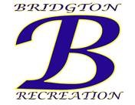Between **swim lessons** and **summer rec** we have 185 children from babies to 15 years old participating in our summer programs. **Fireworks** have been tentatively scheduled for Saturday, September 5th Labor Day weekend. The public has been so nice about making **suggestions** on how to do things and we welcome their input because it also helps make improvements for efficiency.

**General**

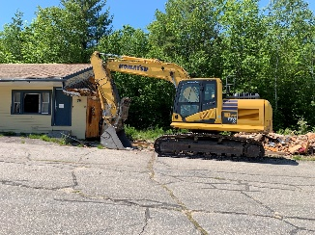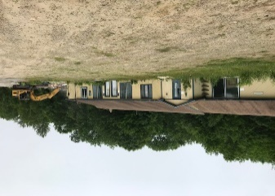On Friday, May 15, 2020 the **First and Last Motel** located at 461 Portland Road was purchased by Mark Lopez and is currently in the process of being demolished.

I am also in the process of planning the **2nd annual Board training** with Drummond Woodsum for Boards and Committees. The training has been tentatively scheduled for Thursday, July 16th and will be held at the Town Hall to maintain social separation. Same as last year attorney Dick Spencer and Aga Pinette will be conducting the training with the same type of format with general discussion at the beginning of the training and then Attorney Pinette conducting a training session for the Planning Board and Appeals Board and Dick Spencer conducting the training session for the Board of Selectmen.

**Bridgton Police Department**

Rick Stillman’s last day on the job will be Friday, June 26th. Rick has worked for the Town of Bridgton as our Police Chief since 2015. We thank him for his years of service to the town and wish him well in his next endeavor.

**Bridgton Fire Department**

The Chief and two members met at Fryeburg Fire station last Thursday night. We will be sending two members to a **basic fire rookie school** in Fryeburg being conducted this summer. Area departments will assist with equipment including Bridgton. It is a pleasure to have a couple younger members willing to participate in the upcoming regional training, and we thank Fryeburg for hosting the training. The department continues to **improve the security** of the entry doors to each station, as recommended by the Town security consultant, new door closures and hardware to be installed, this week. The Department has been busy with various call. We were notified yesterday by the **Maine Forest Service that burn permits** have been shut down due to the extremely dry conditions. They also requested that all towns shut down their permit sites which Chief Harriman has done until such time that the Maine Forest Service lifts the restriction.

**Legion Post 67**

On Wednesday, June 17th there was a tractor trailer set up at the Community Center to distribute food to local veterans. The American Legion sponsored the event. Commander Donald Mulcahy wants to thank town staff, police department and public works for making the first ever food for vets program a phenomenal success. They were able to feed 88 families with a 14 day supply of pantry and food products with folks including Bridgton coming from Fryeburg, Harrison, Denmark, Sweden, Waterford, Naples and Casco. Several vets were signed up to take the Honor Flight Maine and due to feedback they received, will be coming to Bridgton on a regular basis hoping to draw from the surrounding communities with Bridgton as a hub for veterans services. The need is great and now these folks are being represented so we are truly making a difference in people’s lives and I thank Bridgton for supporting your veterans who already gave so much. “Hats off to all of you”.

Until next time.…be safe and be well.

 Respectfully submitted,

Georgiann M. Fleck

Deputy Town Manager