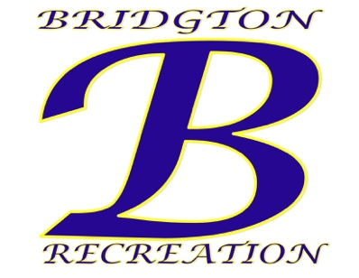
Town of Bridgton
Department of Recreation
3 Chase St. Bridgton, ME 04009
rec@bridgtonmaine.org
207-647-8786

Town of Bridgton – Recreation Department Summer Programs (Seasonal)

The Town of Bridgton, Maine Recreation Department is currently accepting applications for the following summer seasonal positions:
- (9) Lifeguard (Highland Lake, Woods Pond, Salmon Point) {Contingent on Approval}
Applicants must be certified through the American Red Cross Lifeguard/Waterfront certified or become certified before June 15, 2021. Seasonal Full-Time, must be able to work from June 22, 2021 through August 13, 2021.
- (4) Water Safety Instructors (Swim Lessons)
Applicants must be certified through the American Red Cross Water Safety Certification program or become certified before June 15, 2021. Seasonal Full-Time, must be able to work from June 22, 2021 through August 13, 2021
- (8) Youth Development Professionals (Summer Rec & Teen Summer Rec)
Applicants must be at least 16 years old and have desire to work with teens and/or elementary children. Seasonal Full-Time, must be able to work from June 22, 2021 through August 13, 2021.

Contact Gary Colello, Recreation Director for more information. Assistance in finding certification locations, reimbursements for certifications available! All applicants should submit application at bridgtonmaine.org and submit to: Gary Colello, Recreation Director 3 Chase St. Suite 1 Bridgton, Maine 04009.

The Town of Bridgton is an EOE/AAE

