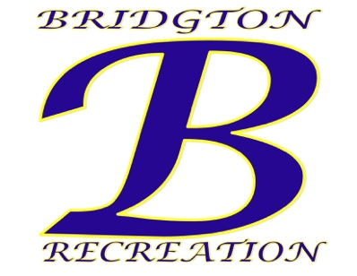
Town of Bridgton
Department of Recreation
3 Chase St. Bridgton, ME 04009
rec@bridgtonmaine.org
207-647-8786

Town of Bridgton – Recreation Department Summer Programs (Seasonal)

The Town of Bridgton, Maine Recreation Department is currently accepting applications for the following summer seasonal positions:
- Lifeguard (Highland Lake, Woods Pond) {Contingent on Approval}
Applicants must be certified through the American Red Cross Lifeguard/Waterfront certified or become certified before June 15, 2023. Seasonal Full-Time
- Water Safety Instructors (Swim Lessons)
Applicants must be certified through the American Red Cross Water Safety Certification program or become certified before June 15, 2023. Seasonal Full-Time
- Youth Development Professionals (Summer Rec & Teen Summer Rec)
Applicants must be at least 16 years old and have desire to work with teens and/or elementary children. The program includes Sports Academy, Theater Camp and a traditional theme based weekly day camp. Applicants with background in Theater, Acting, and Arts are in high need. Seasonal Full-Time

Certification Assistance Available!
Contact Gary Colello, Recreation Director for more information. All applicants should submit application at bridgtonmaine.org and submit to: Gary Colello, Recreation Director 3 Chase St. Suite 1 Bridgton, Maine 04009.

The Town of Bridgton is an EOE/AAE

